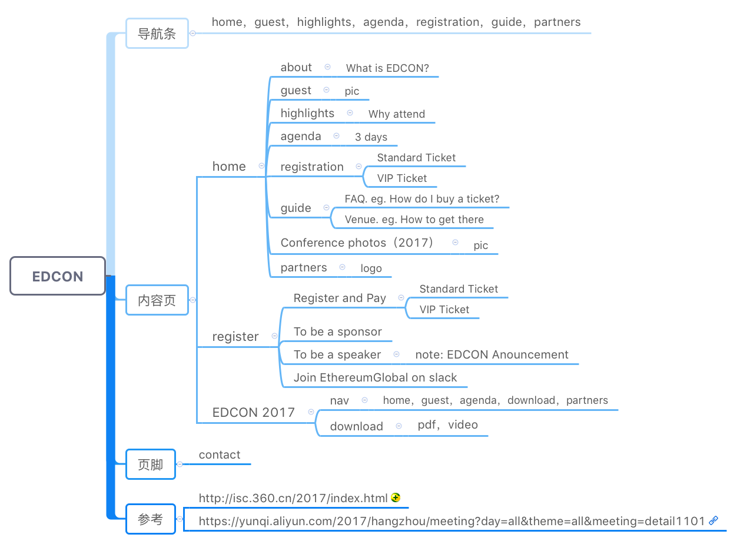**EDCON TORONTO 2018 WEB CONTENT**

**HOME:**

1. **ABOUT**

**What is EDCON?**

The EDCON (Ethereum Development Conference) is the global theme conference organized by LinkTime, the representative of Ethereum community. The conference is mainly to advance the communication, integration and mutual construction of the global Ethereum community. EDCON happens once a year in different countries. It is organized as conference series. The first EDCON was held successfully in ESCP Europe, Paris, France on February 17-18, 2017, and this time, the event will be taking place in Ryerson University, Toronto, Canada on May 2- May 5, 2018.

The conference mainly covers topics about the updated Ethereum Blockchain technologies and researches (Pos, Scalability, Privacy, Casper, etc.) current trends, policies as well as Ethereum and Blockchain based projects and applications. Besides, a Hackason Competition is also in the agenda of the conference.

We sincerely welcome and invite friends from Ethereum communities worldwide to participate in this event. We always keep inclusiveness and fairness in mind when organizing this event, thus opportunities are equal to all participants. The speaker registration channel is available to all, and the topics collected will be reviewed by our consultant team to make sure the conference is highly eye-focused and much worth your coming. This is also one of the reasons that EDCON Paris received so many supports and appreciations. We believe, EDCON Toranto will be the next success with your participation.

**2. How Do I Participate in EDCON?**

The tickets are different according to the identity of participants. You can click registration to find out more about the price and discounts. The earlier you buy the ticket, the more discounts you will be provided.

**二、GUEST:** Vitalik Buterin, Karl Floersch, Loi Luu… TBD

**三、HIGHLIGHTS**

1. Topic: （TBD）This conference covers the topics of Casper…..

2. Why Attend?

* Inspiration and Opportunities

Blockchain is indeed the Next-Generation Technology with an increasing public awareness in 2017. Ethereum certainly plays a significant role in the Blockchain development. The conference, therefore, gathers worldwide experts, developers, investors, and founders of projects and startups from 25 countries over 100 cities, giving you a glimpse into the future trends of the Blockchain technology, and inspiring you to the innovation and helping you find your business partners.

* Connection and Partnership

EDCON Toronto will make it an unforgettable experience as you will get to know more about passionate, inspiring and creative developers, to exchange your thoughts with potential business partners at the sub-conferences, get the opportunity to participate Hackthon and win honorable prizes, also, to be involved deeply in the world of talents. You could also find trustworthy talents or business partners to work with in the long-run.

* Global Talent Database

We spare all efforts in building the global talent database since its creation from last. You will meet the top talents from the world and networking with them.

* Fascinating City, Toronto

Canada boasts incredible support for entrepreneurs, both homegrown and international. As a result, the encouraging environment will stimulate numerous business opportunities for entrepreneurs, researchers, developers and investors.

3. Hackathon

4. Social and Party

TBD

**四、AGENDA**

1. 1ST DAY **MAIN CONFERENCE:**

|  |  |  |  |
| --- | --- | --- | --- |
| **MAIN CONFERENCE** | **TIME** | **AGENDA** | **TOPICS (The orders might be adjusted)** |
| MAY 3, AM | Ethereum Development and Research |  |
| MAY 3, PM | Latest Technologies Exchange |  |
| MAY 4, AM | Discussions on Technologies in Ethereum-based Applications |  |
| MAY 4, PM |  |
| MAY 5, AM | Ethereum Startup Exchanges |  |
| MAY 5, PM | New Products Launch |  |
| MAY 5, Evening | Fun and Social | Cocktail Party |

2. 2ND DAY **SUB-CONFERENCE**

|  |  |  |  |
| --- | --- | --- | --- |
| **SUB-CONFERENCE** | **DATE** | **TIME** | **TOPICS (The orders might be adjusted)** |
| MAY 4 | 10:00-12:00 | **Deep dive into Ethereum:**  Core developers forum  **Guests:**  Vitalik Buterin and other Ethereum core developers  **Participants:**  Core developers, Individuals or organizations interested in researching or want to ask questions about Ethereum  **How to participate:**  VIP ticket, Up to 100 participants |
| 12:00-14:00 | **Startups, Investment and Financing:**   * Entrepreneurs and investors forum * Go-to-Market strategies for Ethereum-based companies（marketing for decentralized startups）   **Guests:**  Investors, Investment companies  **Participants:**  Startups, Investors, Investment companies  **How to participate:**  VIP ticket, Up to 100 participants |
| 14:00-16:00 | **Talents Database:**  Database builders and talents seekers forum  **Guests:**  Linktime Tech and other companies  **Participants:**  Talents, Talents seekers  **How to participate:**  VIP ticket, Up to 100 participants |
| 16:00-18:00 | **Ethereum Community Building:**  Ethereum community global representatives forum  **Guests:**  Ethereum community global representatives  **Participants:**  Ethereum volunteers, European Efans, Individuals and organizations who want to cooperate with or sponsor groups in the Ethereum community  **How to participate:**  Ticket for the main conference |

3. 3RD DAY **HACKASON COMPETITION:**

|  |  |
| --- | --- |
| **HACKTHON**  **COMPETITION** | **DATE** |
| MAY 4- MAY 5  24 HOURS |
|
|
|

**五、REGISTRATION**

1. Registration Info

Registration to be a speaker

Registration to be a sponsor

Registration to join Hackthon

Registration to be a general participant

Join our community (WeChat, Slack, Telegram)

2. Ticket Info.

Standard Ticket: $700 (USD)

Early Bird (the First 100 Tickets): $560 (USD)

Developers Ticket: $350 (USD)

Student Ticket: $210 (USD)

**六、GUIDE**

1. VENUE:

The Ted Rogers School of Management（TRSM） at Ryerson University is Canada's leading diverse, entrepreneurial business school centered in an urban learning environment.

TRSM is developing collaborative, creative leaders who will drive 21st century business forward while making a positive impact on society.

A pioneer in practical, career-focused training, TRSM is at the cutting edge of entrepreneurial, socially conscious and innovative approaches to business.

The Conference focuses on technology, innovation, finance and targets at a better communication and cooperation between developers, startups, investors and Efans. The conference would not be successful without the support of TRSM, we would like to give our sincere thanks for Ryerson University’s help and cooperation.

2. FAQs:

* Q: How many tickets are available in total?

A: We plan to have up to 600 participants in total, including EDCON staff and volunteers. An early registration and purchase for the pass is highly recommended as you can get a good discount if you are an early bird.

* Q: How can I buy tickets?

A: You can click Here to buy and pay for the ticket accordingly, or move to the Registration page to find out more.

* Q: How to get to the venue?
* A: The venue is located in Ryerson University, 350 Victoria Street, Toronto, Ontario M5B 2K3. You can take Toronto Transit Commission (TTC), Go Transit, Via Rail Train, Greyhound Bus, Bicycling, Car, Taxi to the location.

**Toronto Transit Commission (TTC)**

Toronto has a public transit system, complete with underground subways, rapid transit (RT), streetcars and buses. The Toronto Transit Commission (TTC) operates this system and publishes a free transit map that is available from any subway station, at ISS in POD-61, or click [here](http://www.toronto.ca/ttc/schedules/index.htm) to download a copy.

The cash fare for an adult is $3.00 cash per person per ride. You can also purchase prepaid fares such as tokens, tickets or monthly passes that are slightly cheaper than the cash fare. If paying by cash, exact change is required on buses and streetcars.

There are two subway stations located near Ryerson:

1. Dundas Station is also located within the Eaton Centre at Yonge and Dundas, and has entrances to and from the street.
2. College Station is located at Yonge and College/Carlton and can be accessed within the College Park mall.

The TTC has a route information service that can help you find out how to get to a particular address via subways, streetcars or buses. The TTC's customer information phone number is (416) 393-4636. Visit the [TTC](http://www.ttc.ca/) website for more information.

**GO Transit**

For travel between Metro-Toronto and surrounding areas, use GO Transit at: [www.gotransit.com](http://www.gotransit.com/). A student discount application is available for both GO trains and GO buses the One Card Office. For more information, visit:<http://www.ryerson.ca/onecard/gotransit/>

**VIA Rail Train**

VIA Rail is the Canadian railway and offers service to many cities and towns. They offer a discount to travelers less than 25 years old. For schedules and other route and ticket information, please call 411 or visit the VIA website at [www.viarail.ca](http://www.viarail.ca/)

**Greyhound Bus**

Greyhound is the largest bus company in Canada and offers service from Toronto to many cities and towns. Visit the [Greyhound](http://greyhound.ca/) website for more information.

**Car (TBD-需要与Susan double check)**

Use caution whenever driving downtown due to the volume of cars, pedestrians and road restrictions. Purchase of a road map is advisable. Driving licenses are required and there are free Driving Regulations books available from most Ministry of Transportation offices (consult blue section of white pages for phone numbers).

If you have a valid [Driver's License](http://www.drivetest.ca/en/license/License.aspx) and wish to rent a car, there are many car rental businesses providing that service in Toronto. For a typical day rental, the rate is generally $50 a day (including insurance and sometimes mileage). The absolute minimum car rental age is 21 years old and all businesses require a credit card as a deposit.

Parking in a public parking lot is expensive in downtown Toronto. Both Jarvis Street and Church Street have coin meter parking, however, it only allows a maximum of 2 hours on the time meter. It is important to note that on the vast majority of main streets downtown, parking and stopping is prohibited during morning and evening rush hours. Remove your car during those hours or it will be towed-away and you will be fined. Please check with street signs before parking. If you wish to park on Campus, applications for student parking are available from room A1108 (11th floor Jorgenson Hal). The cost per school year is approximately $ 1,150 (including taxes). For more information, [click here](http://www.ryerson.ca/ubs/parking/vehicle.html).

If driving in snowy and icy conditions is new for you, we recommend that you take a seminar on winter driving.

**Taxi**

There are several cab or taxi companies operating in Toronto. Cab fare begins at $4.00 (or higher) as soon as you step into it. Tipping (7% to 10%) is a customary practice but not mandatory. Cash is an acceptable method of payment and sometimes credit card.

* Q: Are there any good places to visit around the venue?

A: Toronto, the capital of the province of Ontario, is a major Canadian city along Lake Ontario’s northwestern shore. It's a dynamic metropolis with a core of soaring skyscrapers, all dwarfed by the iconic, free-standing CN Tower. Toronto also has many green spaces, from the orderly oval of Queen’s Park to 400-acre High Park and its trails, sports facilities and zoo. Ryerson University is located in the center of Toronto, surrounding by the central shopping mall, CF Toronto Eaton Centre, which is just a step away from Ryerson University. There are full of Hotels and Restaurants near by and the CN tower is only 1.7 km away from Ryerson University.

* Q: Will there be any video recordings of the event?

A: Yes, there will be video recordings of the wonderful presentations /demos /activities, and of course hackathon is included, and they will be uploaded to our website.

* Q: Can I watch the live stream of the conference online?

A: TBD

* Q: Where can I download the presentations from the speakers?

A: you can download from our website; the link is…

* Q: How to register the talent database?

A: TBD

**7. PARTNERS**: TBD

About Us:

LinkTime is a startup that primarily develops applications on Ethereum and provides Ethereum-based blockchain and smart contract solutions. LinkTime works closely with core Ethereum developers and researchers, and it helps to advance the Ethereum ecosystem through technological development, training and promotions.